PROGRAM 2 (CO1)

AIM:Write a program that demonstrates Activity Lifecycle

XML

*<?*xml version="1.0" encoding="utf-8"*?>*<LinearLayout xmlns:android="http://schemas.android.com/apk/res/android"  
 xmlns:app="http://schemas.android.com/apk/res-auto"  
 xmlns:tools="http://schemas.android.com/tools"  
 android:layout_width="match_parent"  
 android:layout_height="match_parent"  
 android:orientation="vertical"  
 tools:layout_editor_absoluteX="1dp"  
 tools:layout_editor_absoluteY="1dp"  
 tools:context=".MainActivity">  
  
 <TextView  
 android:layout_width="wrap_content"  
 android:layout_height="wrap_content"  
 android:text="Hello World!"  
 app:layout_constraintBottom_toBottomOf="parent"  
 app:layout_constraintLeft_toLeftOf="parent"  
 app:layout_constraintRight_toRightOf="parent"  
 app:layout_constraintTop_toTopOf="parent" />  
  
</LinearLayout>

JAVA

package com.example.lifecycle;  
  
import androidx.appcompat.app.AppCompatActivity;  
  
import android.os.Bundle;  
import android.widget.Toast;  
  
public class MainActivity extends AppCompatActivity {  
  
 @Override  
 protected void onCreate(Bundle savedInstanceState) {  
 super.onCreate(savedInstanceState);  
 setContentView(R.layout.*activity_main*);  
 Toast.*makeText*(MainActivity.this,"OnCreate Called",Toast.*LENGTH_LONG*).show();  
 }  
 @Override  
 protected void onStart(){  
 super.onStart();  
 Toast.*makeText*(MainActivity.this,"OnStart Called",Toast.*LENGTH_SHORT*).show();  
 }  
 @Override  
 protected void onRestart(){  
 super.onRestart();  
 Toast.*makeText*(MainActivity.this,"OnRestart Called",Toast.*LENGTH_SHORT*).show();  
 }  
 @Override  
 protected void onResume(){  
 super.onResume();  
 Toast.*makeText*(MainActivity.this,"OnResume Called",Toast.*LENGTH_SHORT*).show();  
 }  
 @Override  
 protected void onPause(){  
 super.onPause();  
 Toast.*makeText*(MainActivity.this,"OnPause Called",Toast.*LENGTH_SHORT*).show();  
 }  
 @Override  
 protected void onStop(){  
 super.onStop();  
 Toast.*makeText*(MainActivity.this,"OnStop Called",Toast.*LENGTH_SHORT*).show();  
 }  
 @Override  
 protected void onDestroy(){  
 super.onDestroy();  
 Toast.*makeText*(MainActivity.this,"OnDestroy Called",Toast.*LENGTH_SHORT*).show();  
 }  
}

OUTPUT

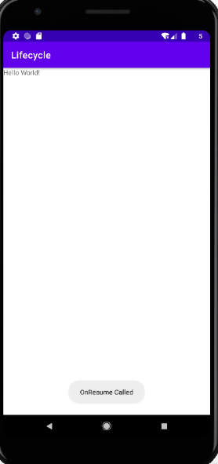

RESULT: Program to demonstrate Activity Lifecycle is successfully executed and output verified